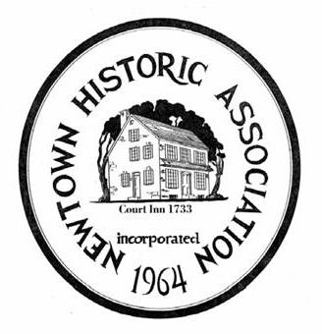

NEWTOWN HISTORIC ASSOCIATION, INC.
Court St. & Centre Ave., Newtown, Pa.18940
215-968-4004

PRESS RELEASE

Newtown Historic Association presents
“Sunday Social at the Half Moon Inn"

The Newtown Historic Association will have a “Sunday Social” held on Sunday, Sept. 14th at 2:00 pm – 4 pm at the Half-Moon Inn, 105 Court St. (Court St. & Centre Ave.), Newtown.

This will be an Open House Reception featuring a tour of the Research Facility, a chance to see the Hicks Hanging Tavern Sign and this is the seat of Newtown History. The Newtown Historic Association is a repository of thousands of items relating to Newtown’s history and also genealogical information of the people who lived here. It is a non-profit organization solely supported by membership dues and contributions and donations from interested parties. All donations go to the upkeep of the facility and of the historic Thornton-Hicks House which is next door which was once the residence of Edward Hicks (famous primitive painter).

The public is invited and refreshments will be served. For further information call 215-968-3914 or visit the NHA Website www.newtownhistoric.org.

Mary Callahan, Publicity

215-968-3914
dcnhh@comcast.net

